***Train Simulation***

Use Case Specification Document

**Case Id 9**

**View Statistics**

Version No. 2.0.0

Project Document Revision History

|  |  |  |  |
| --- | --- | --- | --- |
| **Version Number** | **Date** | **Revision Author** | **Description of Revision** |
| 1.0 | 3/15/19 | Orlando Murrell | Initial Version |
| 2.0 | 4/25/19 | Maxx and Zaid | Update Document according to new specifications and removed any assumptions |

# 

Table of Contents

**1. Introduction** **4**

**2. Use Case Information** **4**

2.1 Actors 4

2.2 Use Case Interaction 4

**3. Trigger** **5**

**4. Pre-condition(s)** **5**

**5. Post-Condition(s)** **5**

**6. Use Case Swimlane Diagram** **6**

**7. Main/Basic Flow(s) of Events** **6**

7.1 Request to view statistics about major components 6

7.2 Request to export data about simulation 6

**8. Alternative/Exception Flow of Events** **7**

**9. Assumptions/Business Rules including Non-Functional Requirements** **7**

# 

# **1. Introduction**

After the simulation has been executed, the user will be able to view various metrics gathered involving stations, trains, hubs, and railways. Metrics include: average railway usage, average train station usage, total train downtime, total train delay, etc.

# **2. Use Case Information**

## 2.1 Actors

|  |  |  |
| --- | --- | --- |
| Actor Name | Role | Description |
| User | Main | This is a human that starts and stops simulation. Select files that would be read and processed. Start simulation to create new day. Weather is decided by user. View files. Add hubs, stations, and tracks. Adjust hubs and stations associated with tracks. |
| Simulation System | Secondary | Run files. Display activity. Show visual representation of simulation graph. |
| UI | Secondary | Show visual representation of simulation graph. |
| File Generator | Secondary | This is a system that will create and and edit files during and of end simulation. |

## 2.2 Use Case Interaction

A list of predecessors use cases are as follows:

Use Case 1: Setup Initial State~~:~~ - Statistics will only be available after the initial state has been set.

Use Case 2: Add / Remove Trains - Statistics would be shown differently when changes are made to the train amounts

Use Case 3: Edit Railway - Statistics would be shown differently when changes are made to the track, hub, and station amounts

Use Case 4: Adjust Weather - Statistics would be shown differently when changes are made to Weather output and Severity

Use Case 5: Update Graph - User changes would apply to a new layout of the graph and would then affect the output of the statistics

Use Case 6: Run Simulation - Statistics will only be available after the simulation has run to the point that it’s possible to compare two states

Use Case 7: Track Statistics - Used to determine what statistics to show the user

Use Case 8: Recommended Changes - Recommendations would change depending on the run. Statistics shown could give the user additional insights on what to change

A list of successors use cases are as follows:

Use Case 10: Rollback Simulation History - User can view previous simulation runs from the statistics that would be available for viewing

# **3. Trigger**

The User requests to ~~either view statistics about major components (Trains, Train Stations, Hubs, and Railways) via the UI or statistics on the entire simulation via an arbitrary interface (the UI or Console)~~ view statistics at the end of a simulation. Once a file is available, user could also have the option to export the data to a CSV file for data modeling purposes.

# **4. Pre-condition(s)**

4.1 Simulation is loaded with valid data

4.2 User runs the simulation for at least one day

1. ~~The Simulation must have executed up to at least one day~~

# **5. Post-Condition(s)**

5.1 UI provides useful statistics to the user on how to optimize the future simulation runs

5.2 Output file is created for the user to view all statistics during the simulation run

5.3 User can export the file to a CSV file type that can be used for data modeling needs

1. ~~The UI displays useful statistics about all major components of the simulation~~
2. ~~A File is output containing useful statistics about all major components of the simulation for data-modeling purposes~~

# **6. Use Case Swimlane Diagram**

~~OLD~~

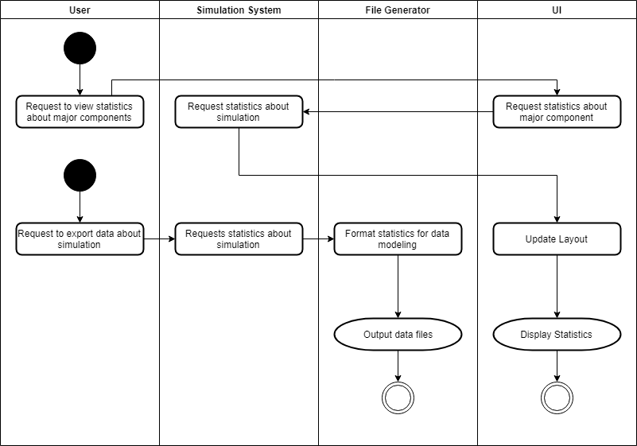

NEW

# **7. Main/Basic Flow(s) of Events**

## 7.1 Request to view statistics about major components

The User requests to view statistics about a major component (train, railway, hub, train station) of the simulation via the UI. The UI queries the simulation system to provide this information, updates its layout, and displays the data.

## 7.2 Request to export data about simulation

The User requests to view statistics about the simulation via the simulation system through the UI. The File generator formats the the statistics for data modeling, and outputs them to a file.

# **8. Alternative/Exception Flow of Events**

# **9. Assumptions/Business Rules including Non-Functional Requirements**

Assumes the file system has enough space to create data files.